- Hierarchy Role based workflow

State Admin (Create Nodal) (Download Excel for data)
⬇
Nodal Collectorate (Create RO Review & Approve RO)
⬇
Reporting Officer - Department Head (Create Inspector & Assign Work)
⬇
Inspector - Assigned work to - Perform inspection survey (for example School/Hospital/Anganwadi)

Please follow proper user creation hierarchy so that intermediary level should also see records of assigned work.

(See about Admin create all users and Nodal can see all user)
(Alternative workaround -> You can take Excel data and download it and use it accordingly)

- In Web geo portal – Created dt will be added by team as per your requirement

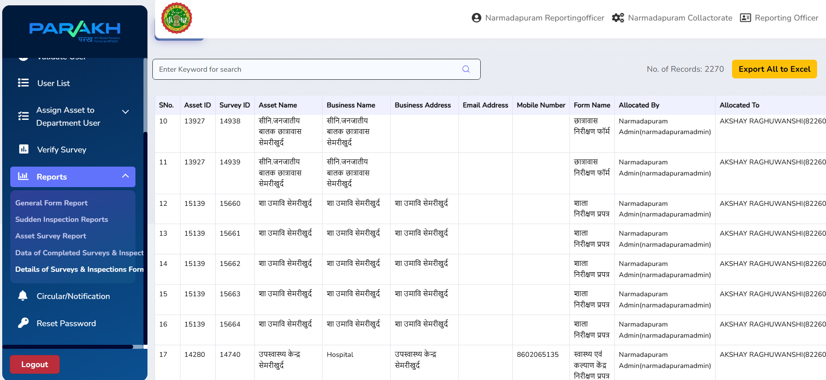

In Excel report “created dt” is visible

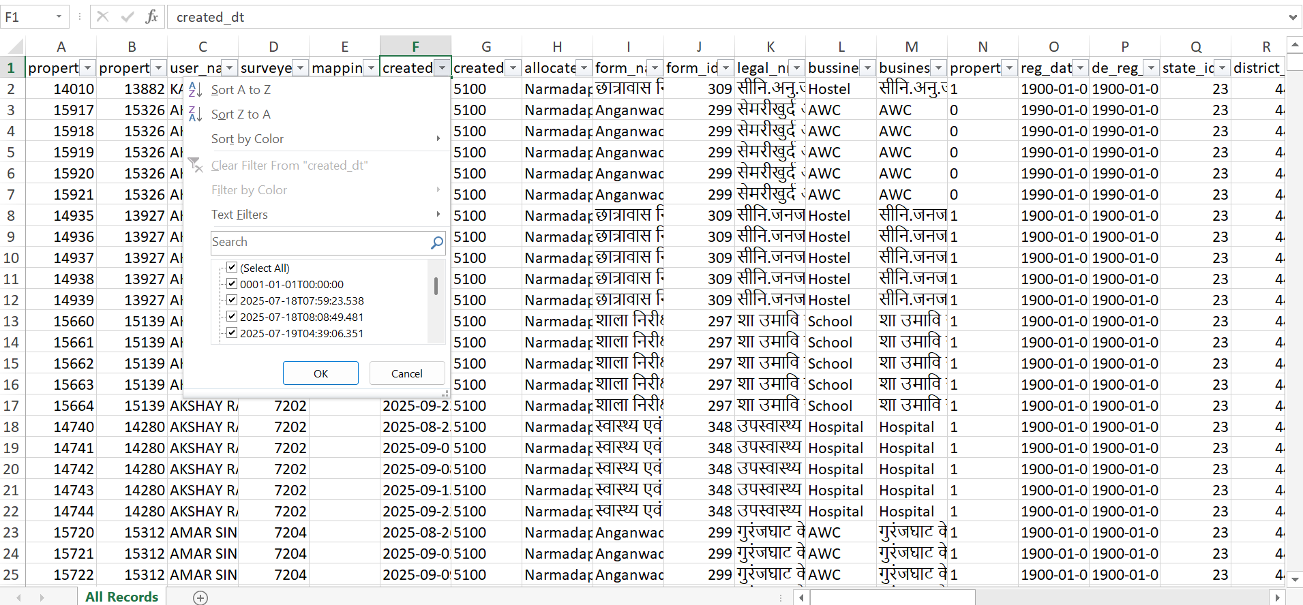

- In Excel report Business Name – Hospital spelling is corrected

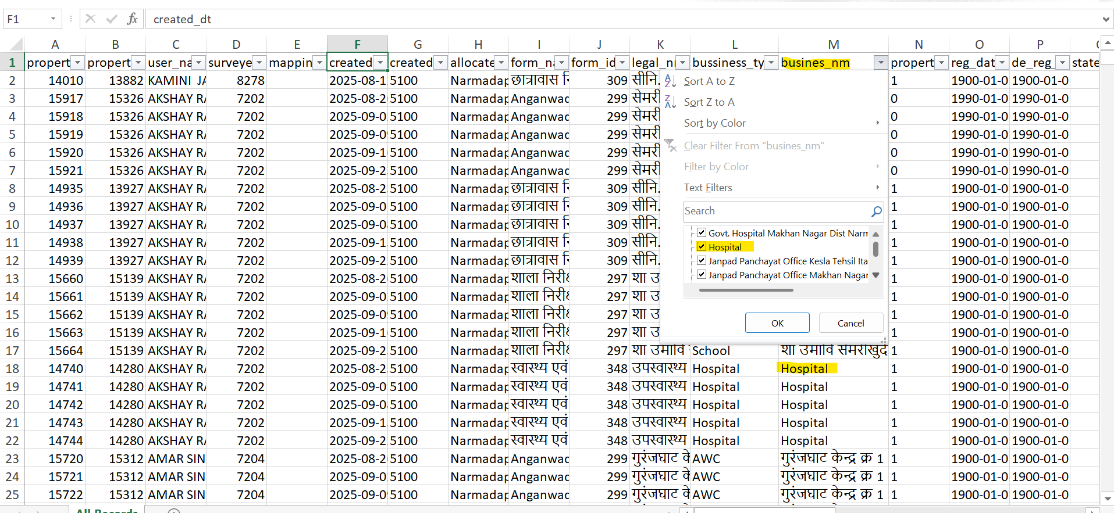

In Web geo portal – Hospital is visible.

